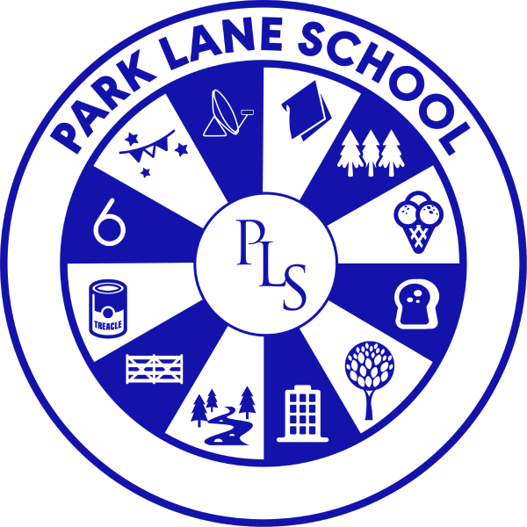

School Development Plan

2024 – 2025

# **School Development Plan**

Our School Development Plan is an operational plan with objectives drawn from the long-term strategic plan, all stakeholders, and from external feedback, including Ofsted and the School Improvement Partner. It is comprehensive with the aim to tackle Ofsted areas for improvement and our own areas for development over the academic year 2024 - 2025.

## Ofsted Inspection 21st & 22nd May 2024

| Area: | | Improvements: |
| --- | --- | --- |
| Quality of Education | Good | * In a small number of subjects in key stage 4 and in the sixth form, the curriculum is not ambitious enough for some pupils. This limits how well these pupils learn and the qualifications that they attain. The school should ensure that the curriculum is sufficiently ambitious for all pupils. * Until very recently, pupils have not received high-quality careers advice and guidance. Moreover, the school does not provide pupils with appropriate opportunities to meet with education and training providers. This limits their knowledge of the options that are available to them when they leave school. The school should ensure that pupils benefit from high-quality careers advice and guidance and have access to a range of education and training providers. |
| Leadership & Management | Good |
| Behaviour & Attitudes | Outstanding |
| Personal Development | Good |
| Early Years Provision | Outstanding |
| Sixth-Form Provision | Good |

## Areas for development – Quality of education

| Objectives: |
| --- |
| * Extend our Values curriculum into KS4 to ensure an ambitious curriculum for all. * Streamline the subject Schemes of Work (SoW) onto a new format and review the content. * Review Park Lane School ‘Lanes’ (assessment) to capture the strengths of every pupil and the breadth of the curriculum. * Explore and introduce appropriate qualifications to enable KS4 pupils to exceed outcome expectations (from good to outstanding). * Ensure pupils benefit from high-quality careers advice and guidance and have access to a range of education and training providers so they can make informed decisions about their own future. * Increase the educational visits offer linked to the curriculum to further broaden pupil experiences. * Expand and increase the offer of work experience opportunities from KS4 to give pupils an understanding of the work environment and possible career options. * Focus on the development of provision for lower school to widen curriculum opportunities that impact upon social, emotional and health outcomes. * Ensure teaching and learning is good or better in all subjects to maintain the exceptional progress our pupils make. |

## Areas for development – Leadership & Management

| Objectives: |
| --- |
| * Further improve the lower school physical environment and facilities to ensure teaching and learning is supported by an inspirational environment. * Ensure the Park Lane staff team is strong, with complimentary skills. * Ensure future planning is in place to increase the Senior Leadership Team (SLT) – Governor strategic meeting. * Lesson observations to become learning visits (frequent, shorter, focused visits) to support judgements of the teaching & learning. * To ensure the school is financially stable in challenging times. * Safeguarding and Child Protection practices to remain well managed. * Investing in our own staff - Staff career progression through national recognised programs. * Review pupil funding with the Local Authority and other Specialist Schools. * Research new appraisal systems for Teachers and TAs to ensure accountability and to give autonomy to staff around their own professional development. * To create a strong Continuous Professional Development (CPD) system based on research and the changing needs of our pupils and the world in which we live today. * Develop a workload and wellbeing plan to prioritise the wellbeing of all staff. * To support Governors to be active and oversee the strategic direction, policies, and overall performance of Park Lane School. |

## Areas for development – behaviour and attitudes

| Objectives: |
| --- |
| * Implement a full-time Outreach Support worker to support mainstream schools with SEND, raising our profile within the community. * Increase the capacity of the behaviour team by recruiting a G7 Behaviour TA and expanding further by introducing a Nurture Team (ELSA) to work in collaboration. * Create safe spaces for every classroom for sensory breaks and individual needs. * Investigate and devise a sustained plan to increase the capacity for sensory Occupational Therapy to benefit every pupil at Park Lane. * Increase pupil voice through the introduction of Pupil Safeguarding Ambassadors. |

## Areas for development – Personal development

| Objectives: |
| --- |
| * Ensure continued strength of curriculum enrichment practices to inspire pupils to develop interests outside of the classroom. * Increase the opportunities in Preparing for Adulthood (PfA) by introducing residential opportunities for KS3 and above. * Review the Personal, Social, Health, and Citizenship Education (PSHCE) curriculum to ensure Healthy lifestyles are promoted well throughout school i.e. healthy eating * Maintain our strong mental health practices through My Happy Minds (MHM) curriculum. * Review and quality assure our careers practice - Achieving the national Quality in Careers Standard award. * Maintain and further strengthen parental engagement through FOPLSS partnership. |

|  |  |
| --- | --- |
| **Summary of SDP 2024 – 2025** | |
| **Impact linked to SDP objectives** | **🔹 Quality of Education**  **Impact:**   * **Ambitious KS4 Curriculum**: KS4 pupils now access a cohesive, aspirational curriculum aligned with the whole school, improving progression and engagement. * **Improved Teaching & Learning**: Introduction of the “Steps to Independent Learners” approach has led to more consistent, high-quality teaching. * **Qualifications & Exam Centre**: Pupils now access Entry Level Maths, ASDAN, and other qualifications, raising attainment and post-16 readiness. * **Careers & Work Experience**: Increased access to careers advice and real-world experiences has broadened aspirations and informed decision-making. * **Educational Visits**: Enhanced curriculum-linked visits have deepened learning and engagement. * **Curriculum Enrichment**: Lower school provision now better supports social, emotional, and health outcomes.   **🔹 Leadership & Management**  **Impact:**   * **SLT Restructure & DHT Appointment**: Strengthened leadership capacity and succession planning. * **CPD & Appraisal Systems**: Staff development is now more targeted, with clear career pathways and accountability. * **Environment Improvements**: Refurbishments (Reception, EYFS, classrooms, sensory room, outdoor spaces) have enhanced learning environments. * **Wellbeing & Workload**: Staff wellbeing initiatives (e.g., SMHL training, wellbeing surveys, staff clubs) have improved morale and retention. * **Governance**: Governors are more visible and engaged, providing effective challenge and support.   **🔹 Behaviour & Attitudes**  **Impact:**   * **Expanded Behaviour & Nurture Team**: More targeted support for pupils with SEMH needs and those pupils who are not attending school. * **Sensory Spaces/resources**: Pupils better able to self-regulate, improving engagement and reducing incidents. * **School Council & Safeguarding Ambassadors**: Pupil leadership in school/safeguarding has increased awareness and ownership. * **Outreach Support**: Park Lane’s expertise is now shared with mainstream schools, raising its profile and supporting inclusion.   **🔹 Personal Development**  **Impact:**   * **Forest School & Outdoor Learning**: Boosted creativity, physical health, and emotional wellbeing. * **Residentials & Clubs**: Broadened experiences and developed independence. * **Healthy Lifestyles**: New catering and awareness weeks have promoted better food choices. * **Careers Award Journey**: Strengthened CEIAG provision with national recognition in progress. |