What’s it all about?
Speech and Language Therapy at Park Lane School

Sing Sign and Symbol lunchtime club
Music and songs are great fun and help stimulate language development. ‘Sing Sign and Symbol club’ provides opportunities for pupil’s using all forms of communication to join-in with a group musical activity.
When: Monday lunch time 1:00 – 1:30
Where: School Hall
Who is it suitable for: Any students who enjoy music / dancing / singing
Aims:-
- improve listening skills
- increased familiarity with core words
- increase recognition of core words in spoken / symbol / sign form
- to use core words in spoken / symbol / sign form
Support Strategies:-
- Alternative and Augmentative Communication (AAC). Please bring each student’s individual communication aid.

- Core Vocabulary. Core Vocabulary are the highest frequency words that make up most of what people say across most contexts. So, core vocabulary words are very important to learn. Please refer to the core vocab in pupil’s communication books or the core vocab sheets provided by the Speech and Language Therapy team.

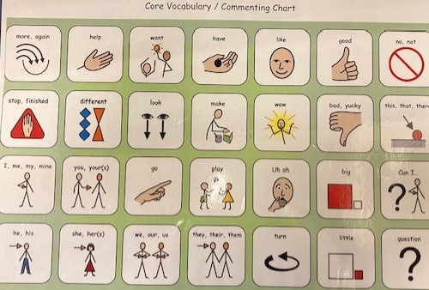

- Modelling. Modelling just means saying the right word at the right time, pointing to the symbol that matches the word being spoken at that time, and / or, signing the signalong sign to match the word. Modelling imitates natural language development, teaches the words, helps with generalising words, reduces the pressure” (ref Liberator)

The Speech and Language Therapy team model vocabulary using sign and symbol for many words in each song during Sing Sign and Symbol. This is beneficial for pupils to see a ‘fluent’ and full model of these communication methods, (just as a young typically developing child would be emersed in a fluent speaking environment). However, most students will need the staff supporting them to pick out and model a smaller number of signs / symbols. e.g. some pupil’s may be working on using one sign or symbol at a time and may benefit from the staff supporting them choosing just one or two signs / symbols from each song and modelling these repeatedly.

- Singalong. “Signalong is a key word sign-supported communication system based on British sign language and is used in spoken word order. It uses speech, sign, body language, facial expression and voice tone to reference the link between sign and word.” www.signalong.org.uk.

Please don’t hesitate to ask the Speech and Language Therapy team for further advice on supporting individual pupil’s needs during Sing Sign and Symbol. Please also don’t hesitate to ask about the choice of signs and symbols used in each song. We are always happy to change / adapt signs and symbols to fit as closely as possibly to the most commonly used signs / symbols in school and welcome feedback on this to ensure consistency for pupils.

