Mulberry Class
WK: 1st June 2020
Area | Activity | Links
English | Story, song or rhyme: Noah’s Ark  Fine motor skills: Animal description - Get the children to think of all of the different animals that might have been on Noah's ark. Get them to choose their favourite animal and describe it. They could also create a new animal by taking parts of different animals and sticking them together. They could then describe the new animal and do a drawing to go with lt. (Use the symbol board to describe the animals.)  Communication: Use the communication storyboard or tactile animals to join in with the story, pass comments or answer questions about the story.  Reading & Phonics: – Reading books / Education City login. | Noah’s Ark PowerPoint story – see distance learning tab.
Maths | Practice counting in 2s with the help of the animals that are on Noah's ark. (If you have any animals at home, you could use these.) Give the children pictures/objects of pairs of animals and encourage them to count in twos to find out how many animals and how many pairs of animals.  Addition and subtraction with animal legs — Use pictures of different animals to practice counting and adding. So for example, you might have one cows and two ducks. The children will have to count the total number of legs on each side of the calculation and then add them together. So if you had the picture of the animals, they then have to write out the calculation (4+4=_) and solve it. | https://www.youtube.com/watch?v=0mrbhsusOGM  See counting legs attachment.  Education City – parent login
Creativity | Learn the song – The animals went in two by two.  Cotton wool rainbows - In the story It ends with a rainbow. Get the children to create a rainbow using cotton wool balls. Get them to place the cotton wool balls In the shape of a rainbow and then get them to paint It In the correct colours.  Colour mixing - Look at primary colours and practice mixing colours to get the other colours of the rainbow. Create a colour wheel.  Paint bubbles - Get some bubble mix, or make It yourself from washing up liquid and water. Add powder paint to the solution and get the children to blow the mixture on to paper. Try In all the rainbow colours. | See YouTube link above.
Individuality | Help at home with the washing and drying. Sort out pairs of socks to wash, hang them out to dry and then fold the matching pairs!
Community | Look at the story and the symbols in the story - the dove and the rainbow. Look at what they represent. Read the story and discuss what we can learn from it. We need to look after the planet and listen to God. It is important to tell children this is what some people believe, but it is up to each individual as to what they believe in. | 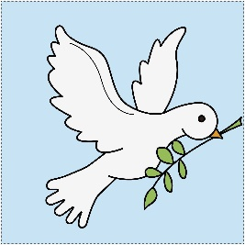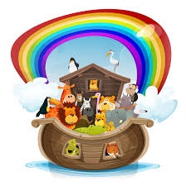
Challenge | Grow a rainbow!  Create your own weather in a cup. You could create a rain cloud with a clear plastic cup, filled ³/4 full of water. Then put shaving cream on the top. Explain that the shaving foam is the cloud, and then pour blue food colouring on top and watch it rain. | See the attached method below.
- Please refer to annual reviews for your child’s personalised targets.
I would love to see and hear about what you have been doing, feel free to email myself anytime – eshaw@parklane,cheshire.sch.uk

