Mulberry Class
WK: 4th & 11th May 2020 - I hope everyone got their special letter from the postal worker
Area | Activity | Links
English | Story, song or rhyme: Jim and the beanstalk. Listen and join in with the repetitive phrases in the story using the YouTube link.  Fine motor skills: Opening packets, tins, jars etc. to help out in the kitchen with breakfast, lunch and dinner.  Communication: Learn the signs (posted on Facebook) for colours and have a go at singing the colours of the rainbow song. Use any opportunity to make and confirm choices using personalised communication systems.  Reading & Phonics: – Reading books / Education City login. | https://www.youtube.com/watch?v=IiizHAry5aU  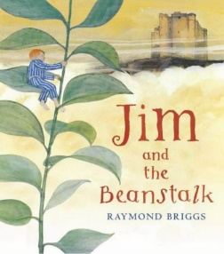
Maths | Measuring games – Use the story ‘Jim and the beanstalk’ to measure your head, body, hands etc. Use standard and non-standard units of measure. (Make your own tape measure from paper if you haven’t got one.) | Education City – parent login
Creativity | Sing along with the lyrics and music of Fee-fi-fo-fum! Add some actions to the song and get stomping around! | https://www.youtube.com/watch?v=Tn-ZSizEdMI
Individuality | Cosmic Kids yoga dance party! Have fun learning new moves or join in when you can. | https://www.youtube.com/watch?v=23VdtT0vQUY
Community | You may find caterpillars and snails crawling up a beanstalk….Create beanstalk leaves and add rolled paper snails to them – even add the snails to your houseplants and give you family a scare! | 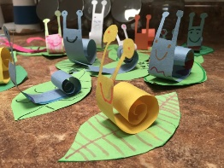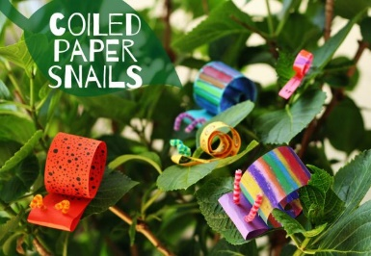
Challenge | Look at the link - Go, Slow, and Whoa as a way to think about food. Think of the healthiest foods as "go" foods. These are foods like steamed or raw veggies and skim or low-fat milk that are good to eat almost anytime.  Foods that are OK to eat sometimes are "slow" foods. Foods like hamburgers or pancakes are not off limits - but they should not be eaten every day. At most, you will want to eat these foods just a couple of times a week.  Some foods should make you stop, think, and say, "Whoa! Should I eat that?" These foods are the least healthy. They are the most likely to cause weight problems, especially if a person eats them all the time. "Whoa!" foods are once-in-a-while foods, like French fries or ice cream.  Have a go at Freddy Fit lunchbox maker game.  (*Please ignore this section if you do not eat food.) | https://kidshealth.org/en/kids/go-slow-whoa.html  https://www.freddyfit.co.uk/kids/games/lunch-box-maker.php
- Please refer to annual reviews for your child’s personalised targets.
I would love to see and hear about what you have been doing, feel free to email myself anytime – eshaw@parklane,cheshire.sch.uk

