Mulberry Class
WK: 20th & 27th April 2020
Area | Activity | Links
English | Story, song or rhyme: we’re going on a bear hunt. Listen and join in with the story using the YouTube link or the sensory story below.  Fine motor skills: Think about going out on an adventure to find a bear…Write a list of items or collect the real objects that you would need. (A sandwich for the journey, map, drink, bag, camera etc.)  Communication: Learn the signs (posted on Facebook) for breakfast and drinks. Use any opportunity to make and confirm choices using personalised communication systems.  Reading & Phonics: – Reading books / Education City login.  Environmental sounds – Focus on listening - Watch the YouTube clip or go outside with the symbols (blank cells to fill in yourself) and point to what you can hear. Can you hear anything else? | https://www.youtube.com/watch?v=Iou5LV9dRP0  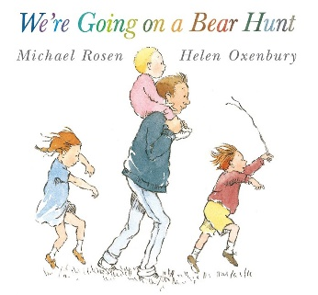  https://www.youtube.com/watch?v=OotUxIesQBM
Maths | Hide bears or other toys around the house/garden, describe their location using positional vocabulary – in, on, under, next to, behind etc. to find them.  Make sandwiches to take along on your bear adventure – follow instructions and cut the sandwiches into shapes, group the shapes and compare sizes/shape. | Education City – parent login
Creativity | Host your very own ‘Teddy Bears Picnic’ and invite all your bears! Create colourful bunting, make sensory textured bears to decorate the room, create a den for the picnic and of course don’t forget the music. | 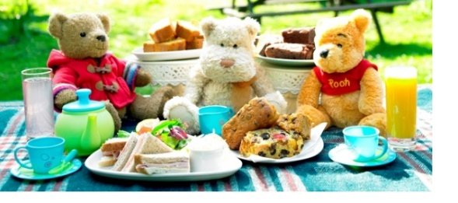
Individuality | Dress up! Have a variety of clothes & shoes to represent the different weathers linked to the story. Encourage your child to dress up as independently as possible (great for fine and gross motor skills) or model dressing skills on yourself! (Ask your child to pick out the correct clothing for the weather or the sequence in which you are to get dressed.)  Grass – T-shirt, shorts and shoes  River – Swim kits no shoes  Mud – waterproofs and wellies  Forest – Big coat  Snow – Hats, scarves and gloves  Once dressed role play the story and copy actions.  Cosmic Kids bear hunt yoga. | https://www.youtube.com/watch?v=KAT5NiWHFIU
Community | Create bear hunt maps, link to maths and use positional language to follow the instructions on the map.  https://www.twinkl.co.uk/resource/t-t-22252-bear-hunt-story-map-activity-sheets  How old is your teddy bear? …. Can you believe Emma’s bear is 40 years old!!!! | 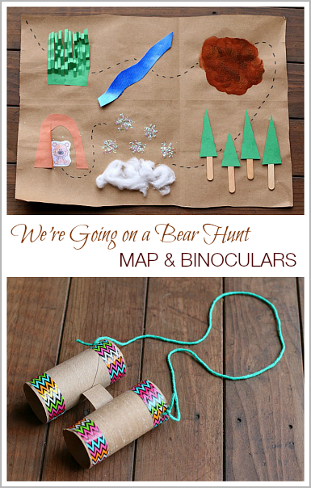
Challenge | Create and decorate binoculars using toilet paper rolls to take on your bear hunt! (I know toilet roll!)  Put a teddy in your window facing the road and as people are out getting fresh air and exercise, they can enjoy the bears around their neighbourhood – take photos of the bears you find.  APP - We’re Going on a Bear Hunt 4+  £2.99  The brand new and official game of ‘We’re Going on a Bear Hunt’, based on the award-winning book by Michael Rosen and Helen Oxenbury and animated film by Lupus Films. https://apps.apple.com/gb/app/were-going-on-a-bear-hunt/id1164891129
- Please refer to annual reviews for your child’s personalised targets.
I would love to see and hear about what you have been doing, feel free to email myself anytime – eshaw@parklane,cheshire.sch.uk

