Hello everyone,
Here are some fun Art, Drama and Music activities for you to try.
They are all based around trips out. Hopefully, you will all be able to visit some of the following places, during the summer holidays
Each set of activities is connected to our different classes. Look at other class activities for extra inspiration.
We hope you enjoy our activities

From the Creativity Team

Silk Class Activities- A Day on Southport Beach
Southport beach really does boast some of the most amazing views of the coast. With long sandy beaches and a coast-line that stretches 22 miles across Sefton, you can soak up the panoramic view of golden sands and admire the beauty of the coast!

Art Activities- Lots of seaside ideas
A Day at the Seaside
Make a sand picture
Using coloured sand (add powder paint or grated coloured chalk to sand)
(for fake coloured sand add food colouring to salt )
Dribble glue onto the paper and then add the sand shake off any excess sand and leave it to dry
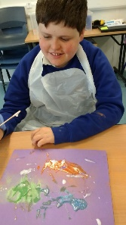
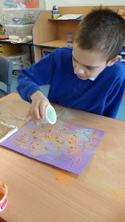
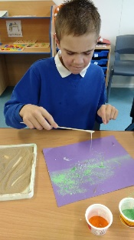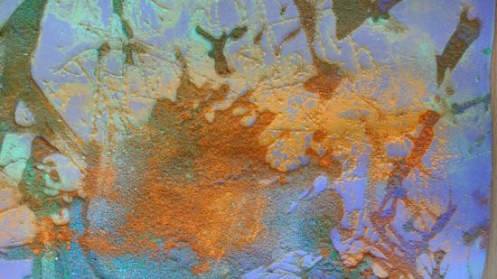

Make a sand sculpture with kinetic sand
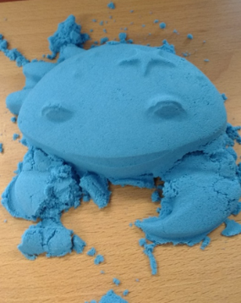
DIY Kinetic Sand
For instructions https://www.youtube.com/watch?v=i7nd2_eUoxw

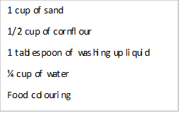

Use puffy paint and a cardboard triangle to make an ice cream
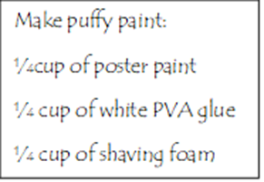
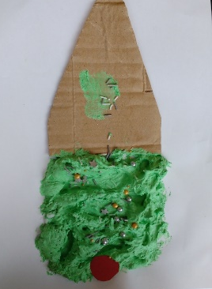

make model ice creams with frosting dough
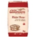
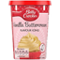
Add icing sugar or flour to ready-made frosting (buttercream) to make edible playdough
Add food colouring and sprinkles to decorate

Make some paper plate seaside creatures
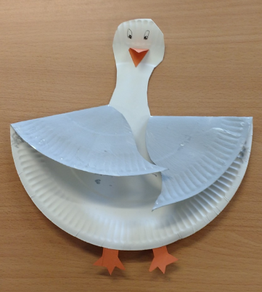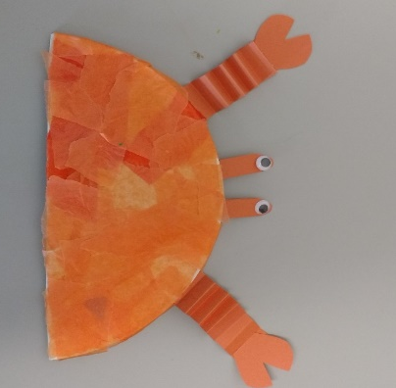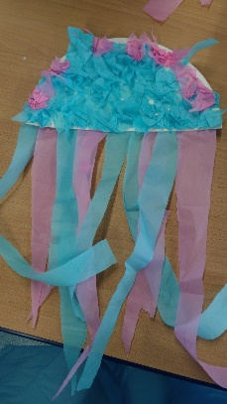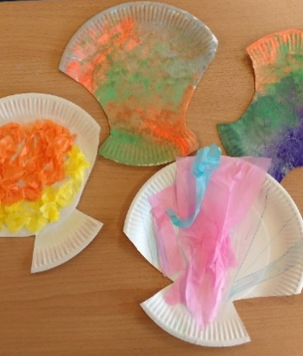

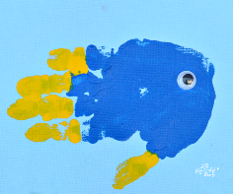
Make seaside handprint pictures
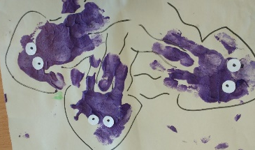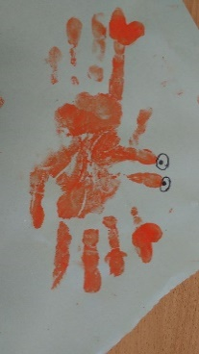

Make a puffy sand paint seascape
Use blue puffy paint and shaving foam
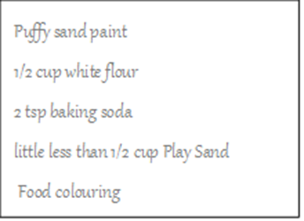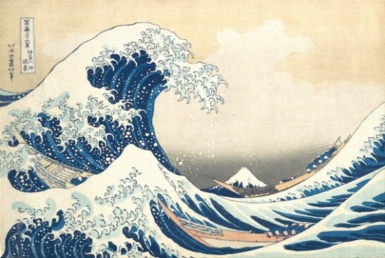

Make some shell shapes with Sand playdough
Sand playdough
1 cup of all-purpose flour.
1 cup of fine beach sand {not craft sand}
1/4 cup of salt.
1 tablespoon of cream of tartar.
1 tablespoon of vegetable oil.
1 tablespoon of glycerine.

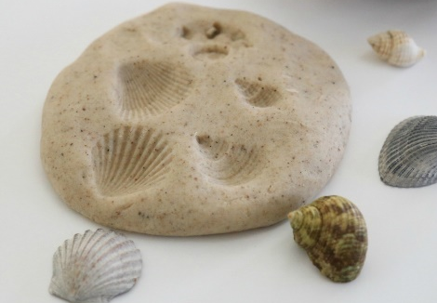

Music- Sing along with some seaside songs
Sung to: "London Bridge"
We are going to the beach, to the Beach, to the beach,
We are going to the beach, in our bathing suits.
We will find there rocks and shells, rocks and shells, rocks and Shells.
We will find there rocks and shells, to gather by the water.
We will build a sand castle, sand castle, sand castle,
We will build a sand castle, with bridges and a tower.
We will have a picnic too, picnic too, picnic too,
We will have a picnic too, with sandwiches and oranges.
Home we head with sunburned cheeks, sunburned cheeks, sunburned cheeks,
Home we head with sunburned cheeks, and treasures from our visit.

Sung to: "Frere Jacques"
Days are longer, sunshine's stronger. Summer's here! Summer's here!
Let’s jump through the sprinkler, let’s make lemonade,
Summer's here! Summer's here!
I see sea gulls, I see sea gulls, at the beach, at the beach,
Soaring, diving, fishing, soaring, diving, fishing, at the beach, at the beach.
I hear the ocean, I hear the ocean, at the beach, at the beach,
Crashing, splashing, foaming, crashing, splashing, foaming, at the beach, at the beach.
Sung to :”Put your finger on your head”
Put a hat on your head, on your head (x4)
Put sun cream on your face, on your face (x4)
Play under a tree, under a tree (x4)
When you're playing outside have some fun (x4)
Play out of the sun, in the shade (x4)
Sung to: "A Hunting We Will Go"
Let's go to the beach, to swim and play and run.
Building castles in the sand, is always so much fun.
We'll fix a picnic lunch and eat it when we like.
And when we all are nice and full, we'll take a nature hike.
Be sure to wear your suit, and bring along your float.
We'll ride so far out in the surf, pretending it's a boat.
We'll find some pretty shells, and throw the gulls some bread.
Put on a lot of suntan oil, so that we don't turn red.
We'll never want to leave. great fun this all has been.
We'll come back another day, and do it all again!

Drama

Create a beach
Equipment:
Box of sand
Jug of water
Plastic boats
Plastic sea creatures
Bucket/ yogurt pots
What to do:
Encourage children to push the sand to one side of the box to create your beach.
Let the children pour the water into the box to be the sea.
Let children put boats onto the sea and any sea life into the water.
Build and knock down sandcastles on the beach.
Purpose:
Using the hand as a shovel promotes arch formation in the hand.
The tactile input will vary between sand, water and mud.
Pouring will increase wrist strength.

Granelli Class Activities- A Visit to the Seaside

Music- Sing along with some seaside songs
Crab song ( sung to: John Brown’s Body)
Five cranky crabs were digging on the shore. (x3)
One got caught in a fishing net, and then there were four.
Four cranky crabs were floating in the sea. (x3)
One got trapped in seaweed and then there were three.
Three cranky crabs were wondering what to do. (x3)
One went in a hole and then there were two.
Two cranky crabs were warming in the sun. (x3)
One got scooped up in a bucket and then there was one.
One cranky crab was smarter than his friends (x3)
He hid between the jagged rocks. That's how the story ends.

3. (Sung to: Adam's Family Theme)
When they get into the notion, they jump out of the ocean
With tail fluke locomotion, the Dolphin family
Swim in the sea, eee eee, swim in the sea, eee eee
Swim in the sea, live in a pod
Swim in the sea, eee eee
I bet you didn't suppose, their blow hole was their nose
And in and out the air goes, the Dolphin family
Swim in the sea, eee eee, swim in the sea, eee eee
Swim in the sea, live in a pod
Swim in the sea, eee eee

4.A sailor went to sea, sea, sea.
To see what he could see, see, see.
But all that he could see, see, see.
Was the bottom of the deep blue sea, sea, sea
5. Let's make the motion of the ocean! (Chant)
Jiggle like a jelly fish (whole body moves)
Creep like a sea snail (creep fingers up arm)
Soar like an eagle (move arms above head)
Wiggle like an eel ( whole body moves)
Float like a sea otter ( hands move up and down in floating motion)
Bark like a seal ( head moves in and out)
Walk forward, backward, and sideways like a crab. (hands move sideways up the arm)
5. The fish in the sea go swim, swim, swim
swim, swim, swim, swim, swim, swim
The fish in the sea go swim, swim, swim
In the deep blue sea.
The lobsters in the sea go pinch, pinch, pinch
The octopus in the sea goes wiggle, wiggle, wiggle
The whales in the sea go whoosh, whoosh, whoosh
The crabs in the sea go click, click, click

Art ideas- Make a sand picture
Using coloured sand (add powder paint or grated coloured chalk to sand)
(for fake coloured sand add food colouring to salt )
Dribble glue onto the paper and then add the sand shake off any excess sand and leave it to dry

Make a sand sculpture with kinetic sand
DIY Kinetic Sand
For instructions https://www.youtube.com/watch?v=i7nd2_eUoxw

Use puffy paint and a cardboard triangle to make an ice cream

make model ice creams with frosting dough
Add icing sugar or flour to ready-made frosting (buttercream) to make edible playdough
Add food colouring and sprinkles to decorate

Make some paper plate seaside creatures

Make seaside handprint pictures

Make a puffy sand paint seascape
Use blue puffy paint and shaving foam

Make some shell shapes with Sand playdough
Sand playdough
1 cup of all-purpose flour.
1 cup of fine beach sand {not craft sand}
1/4 cup of salt.
1 tablespoon of cream of tartar.
1 tablespoon of vegetable oil.
1 tablespoon of glycerine.

Drama
Feely Bag
Equipment:
Pillowcase
Two identical small cuddly animals
Two identical, small balls
Two utensils (e.g. a spoon)
Two pebbles, similar shells found on an outing
What to do:
Put one item in the pillowcase
Put the identical item on a table for a visual cue.
Children to put their hand in and point to the same or describe what they feel.
Increase the difficulty by putting more items on the table.
Purpose:
We are linking tactile input to visual input. This helps our students understand the touch properties by simply viewing the objects in their environment. By using hands and fingers to determine what is in the bag we are laying groundwork for fine motor skills. We could introduce new textures in a fun way.

Hovis- A trip to Macclesfield Forest
Art ideas
Visit Mac Forest website
Look at the pictures in the Gallery
http://www.macclesfield-forest.co.uk/gallery.html
Look at these pictures by famous Artists
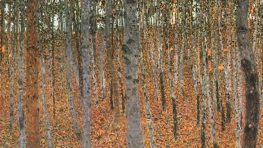 The Beech Forest by Gustav Klimt
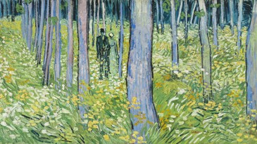 Forest Interio by Van Gogh

Make a forest picture with materials from your recycling
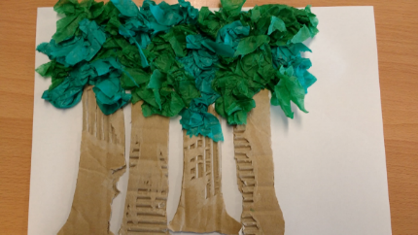
Creatures that live in the forst include beetles, ladybirds, squirrels, dormice, butterflies and moths, tawny owls, woodpeckers and spiders.
Try some potato printing some ladybirds
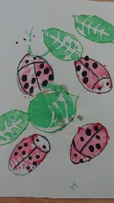

Collect some leaves from the forest (or your garden)
Try printing with leaves
https://www.wikihow.com/Make-Leaf-Prints
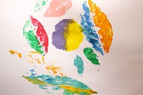

Which animals come out at night?
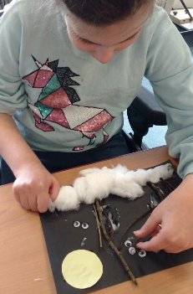
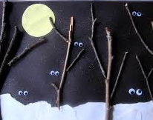
Make a night time forest scene

Make a tawny owl hand print picture
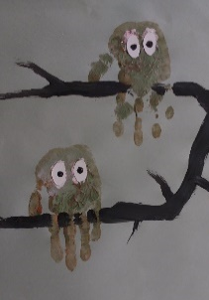

Make mud pies with edible mud
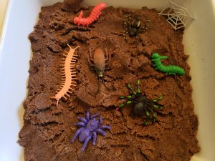
Edible Mud
- 1 x cup Icing sugar
- Water
- 3 tablespoons cocoa powder
- Flour
- ( Add extra water to make runny mud)

Music- Songs and Music inspired by the forest

Listen to each piece of music
- Which is your favourite?
- Which one don’t you like?
- Can you find any other music/songs about Trees and the forest?
- Roar- Katy Perry-
https://www.youtube.com/watch?v=CevxZvSJLk8
- The songs of trees-
https://m.youtube.com/watch?v=e28IYTONXdY
- River deep, mountain high- Tina Turner https://m.youtube.com/watch?v=ULw1RHHPv5g&list=PLAAC05D7C64C61568&index=13&t=0s
- Messing about on the river-
https://m.youtube.com/watch?v=tj9oez8ck8I

Drama

Scooter Safari
Equipment:
Scooter or scooter board or on foot
Plastic jungle toys or laminated pictures. Jungle animals could be substituted for forest animals.
Cardboard box
What to do:
Place the animals around the garden or room. Place the animals under, on, in, in front of, behind objects.
Set up the box, which will be the zoo/forest. You could write “zoo” or “forest” on the box.
Children need to find animals to put in the zoo/forest.
Say the names of the animals and where it was found: “the tiger was under the table”. You could make the animal noises together.
Children to put the animals in their zoo/forest and then look for more animals.
Purpose:
This activity is helpful for gaining command of multistep directions.
Visual-motor skills are used to scan the environment, spot the animal and move towards it.
Development of language using animal names and prepositions.

Mulberry- A Visit to Knowsley Safari Park

Art ideas
Mulberry
At the Safari Park

Visit Knowsley Safari Park website and have a look at some of the animals
https://www.knowsleysafariexperience.co.uk/

Look at the picture of the tiger in a tropical storm in the Picture by Henri Rousseau
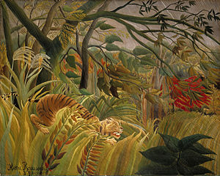
Make a jungle scene collage from materials you have around your house
https://www.nationalgallery.org.uk/paintings/henri-rousseau-surprised

Make tiger stripes and Zebra stripes with shaving foam
Spread shaving foam onto a baking sheet or thick paper.
Drop some food colouring onto the shaving cream and then use a cotton bud or end of a paintbrush to swirl the food colouring around on the shaving cream.
Use orange, black for a tiger, and black for the zebra.
Cover with paper and then peel it off to make a print
Cut out the shape of the tiger or zebra from the marbles paper.

Make a loo roll safari park
How To Make 5 Animals From Empty Toilet Paper Rolls | Easy Kids Crafts
https://www.youtube.com/watch?v=yZ7y9ZJCqv0
Use the cardboard tubes from your toilet paper or kitchen roll to make some jungle animals
Get someone to his then around your house or garden
Use your loo roll binoculars to see how many you can find

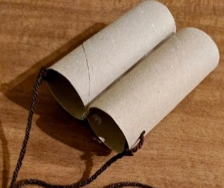

Listen to some Jungle animal sounds
https://www.youtube.com/watch?v=GvxJWsr7uao
Rainforest Animals for Children – Jungle Animal Sounds and Rainforest Wildlife
Can you copy them?
Look at some animal footprints
Watch Who Did the Footprints? | Tee & Mo Story Time
https://www.youtube.com/watch?v=8fI_z-jJMXc
Make some safari animal pictures using your own foot prints
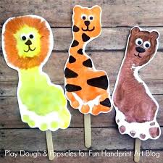

Make a safari scene with playdough
Add items from your home and garden such as:
Grass
No cook playdough recipe
mix
2 cups plain flour
2 tablespoons vegetable oil
1/2 cup salt
2 tablespoons cream of tartar
1 to 1.5 cups boiling water)
gel food colouring (optional)
few drops glycerine
Small cut tree branches
Stalks of bamboo
Stones
Tiny pebbles
sticks
leaves
cut up green paper or plastic
pipe cleaners
pom poms
glass or plastic gems
tooth picks
craft sticks
large beans
pine cones
Add some plastic jungle animals.

Make some shapes with jungle slime

Drama
Create a safari park
Equipment:
Scooter or scooter board or on foot
Plastic jungle toys or laminated pictures.
Cardboard box
What to do:
Place the animals around the garden or room. Place the animals under, on, in, in front of, behind objects.
Set up the box, which will be the safari park. You could write “Safari Park” on the box.
Children need to find animals to put in the safari park.
Say the names of the animals and where it was found: “the tiger was under the table”. You could make the animal noises together.
Students to put the animals in their safari park and then look for more animals.
Purpose:
This activity is helpful for gaining command of multistep directions.
Visual-motor skills are used to scan the environment, spot the animal and move towards it.
Development of language using animal names and prepositions.

Music
Listen to each piece of music
- Which is your favourite?
- Which one don’t you like?
- Can you find any other music/songs about animals?
- The Eye of the Tiger- Survivor
https://m.youtube.com/watch?v=btPJPFnesV4
- The Lion Sleeps Tonight
https://m.youtube.com/watch?v=VT6PARka0
- Dawn Patrol/ Elephant song from Jungle Book
https://m.youtube.com/watch?v=mDYIpMQcYYE
- I wanna be like you- from Jungle Book
https://www.youtube.com/watch?v=9JDzlhW3XTM
- Hakuna Matata- from The Lion King
https://www.youtube.com/watch?v=O_MWcx7n3Iw

Arighi Class Activities- A Trip to Lyme Park or Tatton Park
Lyme Park is a large estate located south of Disley, Cheshire. The estate is managed by the National Trust and consists of a mansion house surrounded by formal gardens, in a deer park in the Peak District National Park. The house is the largest in Cheshire
Tatton Park is an historic estate in Cheshire, England, north of the town of Knutsford. It contains a mansion, Tatton Hall, a medieval manor house, Tatton Old Hall, Tatton Park Gardens, a farm and a deer park of 2,000 acres (8.1 km2).

Art activities-A visit to Tatton Park or Lyme Park
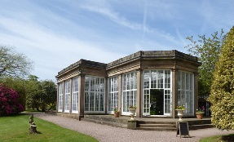
Both Tatton Park and Lyme Park have an Orangery where citrus fruit was grown in the 1800s

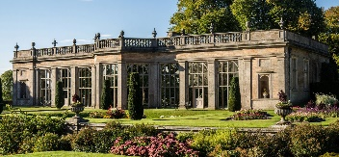
Make a printed picture using oranges and lemons.
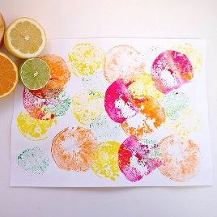
Tatton and Lyme park have beautiful gardens
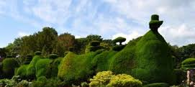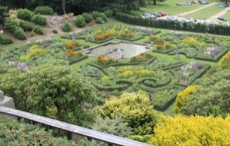
They include trees and hedges cut into interesting shapes. This is known as topiary.
Make a playdough garden
Use your grass playdough with
flowers/ petals
twigs
leaves
Grass
Small cut tree branches
Stones
Tiny pebbles
cut up green paper or plastic
pipe cleaners
pom poms
glass or plastic gems
tooth picks
craft sticks
large beans and pasta shapes
to make a model of a garden.

Make a flower ice sculpture
Pick some flowers from your garden and place in a plastic bowl or mould
Add water and place in the freezer
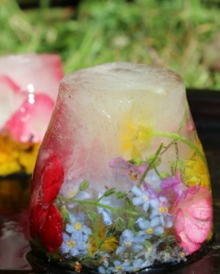

Print a garden.
Try different ways to print some flowers
Dip the bottom of a plastic bottle in some paint and print some flowers
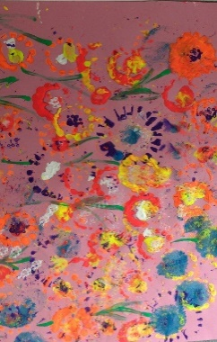
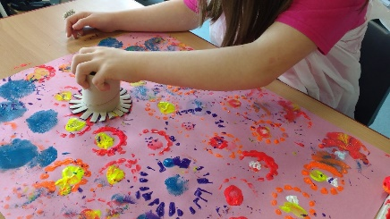
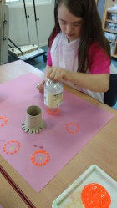
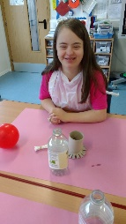
Use a sponge
Use toilet rolls
Cotton buds

You could also try printing with other items you can find around the house such as bottle caps, plastic forks, balloons, Lego bricks, bubble wrap and fingers, hands and feet!
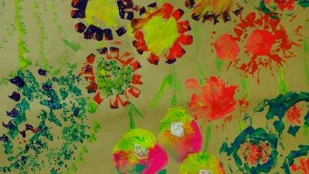
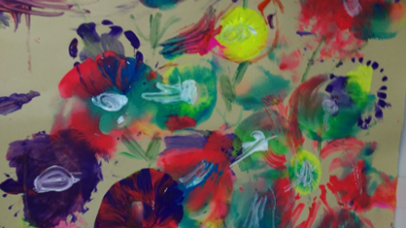

At Tatton and Lyme Park there are Lakes
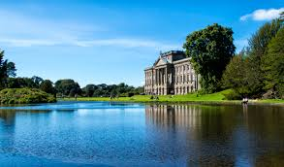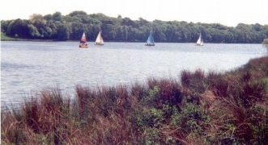
Make some ice boats
Fill an ice tray with water
Add a few drops of food colouring to each ice cube
Put a cocktail stick or straw in each cube, put the tray in the freezer and freeze.
Make sails. Paint a piece of white paper with watercolour paints or water coloured with food colouring. Cut the paper into triangles and stick to the cocktail stick or straw to make a sail.
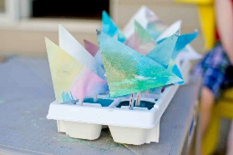
After removing the frozen ice boats from the ice tray, place them in a tray of water to see if they will float.
Watch how the colours mix in the water as the ice melts.
There are deer at Tatton and Lyme Park
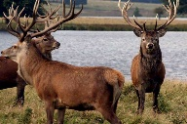
Make a paper plate deer wall hanging.

Music
Listen to each piece of music
- Which is your favourite?
- Which one don’t you like?
Can you find any other music/songs about gardens, plants and trees
- Poison Ivy- The Lambrettas
https://m.youtube.com/watch?v=lwr4mqN1TXY
- Earth day Song- Plant a tree
https://www.youtube.com/watch?v=6wAJ8vuhLGA
- English Country Garden
https://www.youtube.com/watch?v=EUyxCP5Rvco
- Flowers in the window- Travis
https://www.youtube.com/watch?v=AFvfX3Mfd9E
Drama
Let it rain
Equipment:
Coloured and white paper
Scissors
Glue
Plastic to put on the floor if indoors
Glass jar
Blue food colouring
Pipette/ Syringe
What to do:
Cut out umbrellas or a car and make it a car wash
Glue the item to the white paper
Put the paper on an easel, wall or floor
Mix the water and a couple of drops of colouring in the jar.
Pinch the pipette, load the syringe
Let it rain on the umbrella or car
Alternative: Using the pipette/syringe, let students transfer water from one clear cup to another.
Purpose:
Using a pipette or syringe will develop a pincer grasp. As strength increase, encourage use of only thumb and pointer finger.
Encourage children to help with the cutting to promote bilateral coordination.
Treacle- A trip to Chester Zoo
Chester Zoo is a zoo at Upton by Chester, in Cheshire, England. Chester Zoo was opened in 1931 by George Mottershead and his family. It is one of the UK's largest zoos at 51 hectares. The zoo has a total land holding of approximately 160 hectares. It has 35,000 animals to see.

Art -A Day Out at Chester Zoo
Visit the Chester Zoo website
Have a look at the Chester ZPP virtual zoo days
https://www.chesterzoo.org/virtual-zoo-2/
Check out some of the fact files and colouring sheets of animals in the zoo
https://www.chesterzoo.org/schools/resources/?search=

Draw an endangered Orang-utan like Andy Warhol
Chester zoo has a successful breeding programme of the endangered Sumatran orang-utan
https://www.chesterzoo.org/our-zoo/animals/sumatran-orangutan/

Look at pics from Andy Warhol’s Endangered Species series
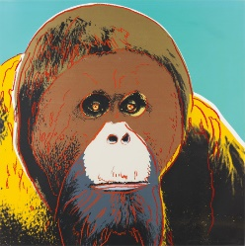
Watch the video showing you how to recreate Warhol’s Orang-utan
https://www.youtube.com/watch?v=cRRyOzKM0tA
PACE Online: Andy Warhol Endangered Animals (Visual Arts Kindergarten Science focus)

Build a Zoo
Use your Lego to make some zoo animals
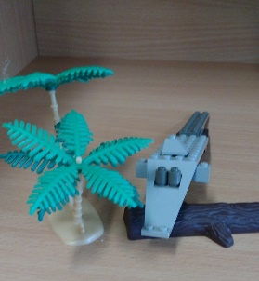
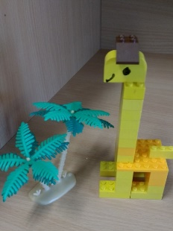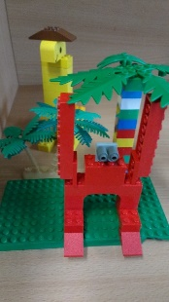

Make a paper chain snake
See pictures of the reticulated python at Chester Zooww.chesterzoo.org/our-zoo/animals/reticulated-python/
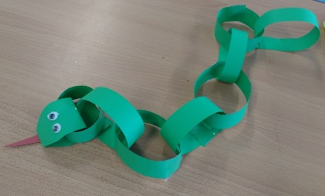
Cut your paper into strips and then in half lengthwise. Roll a strip for the head and tape it into a circle. Thread the next strip through the first, roll and tape to secure. Continue until your snake is as long as you would like it

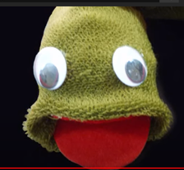
Make a python sock snake
https://www.youtube.com/watch?v=pud76POULuA
How to make a Snake sock puppet - EP - simplekidscrafts

Make a Tapir sock puppet
A rare Malayan tapir was born at Chester Zoo in July 2019
https://kids.sandiegozoo.org/activities/tapir-sock-puppet

Make tiger playdough
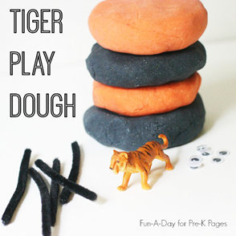
Playdough ingredients:
2 cups all-purpose flour.
3/4 cup salt.
4 teaspoons cream of tartar.
2 cups lukewarm water.
2 Tablespoons of vegetable oil (coconut oil works too)
Orange and black Food colouring.

Bake and decorate some Bear paw cookies
Decorate some cookies or Digestive biscuits with chocolate chips and chocolate buttons

Drama
Body Pointing
Equipment:
Names of parts of the body written or drawn on strips of paper
Hat or bowl
What to do:
Fold the strips and put them into a hat or bowl
Let students pick out a strip, then point at an item using that part of their body.
Other participants must guess the body part.
Purpose:
This encourages students to use body language.
Joint attention skills are developed without the pressure of language

Music- Songs inspired by animals
Listen to each piece of music
- Which is your favourite?
- Which one don’t you like?
- Can you find any other music/songs about animals?
- Little Lion Man- Mumford and Sons https://m.youtube.com/watch?v=lLJf9qJHR3E
- Gorilla- Bruno Mars
https://m.youtube.com/watch?v=AHDtXqjgEj4
- Eye of the Tiger- Survivor
https://www.youtube.com/watch?v=btPJPFnesV4
- Crocodile Rock- Elton John
https://www.youtube.com/watch?v=Y2Ta0qCG8No
- See you later Alligator- Bill Haley https://www.youtube.com/watch?v=1Hb66FH9AzI

6th Form- A day at Alton Towers
Alton Towers Resort is a theme park in Staffordshire, England, near the village of Alton. The park is operated by Merlin Entertainments Group and incorporates a theme park, water park, spa, mini golf and hotel complex.

Drama
Don’t Drop the Ball
Equipment:
Tactile ball, Koosh ball or beanbag
What to do:
Encourage the student to put the ball on their head.
You make faces at the student, who tries to mimic you.
While attempting to mimic, student should attempt to balance the ball.
Purpose:
Balance: Keeping the ball balanced during the mimicking activity requires additional attention.
Social development: By recognising and mimicking facial expressions, students are paying attention to others.
Have fun.

Music- Music inspired by roller-coasters
Listen to each piece of music
- Which is your favourite?
- Which one don’t you like?
- Can you find any other music/songs about roller-coasters?
- Life is a roller-coaster- by Ronan Keeting https://m.youtube.com/watch?v=jqIQ2JvMAH8
- I’m spinning around- Kylie Minogue https://www.youtube.com/watch?v=t1DWBKk5xHQ
- You spin me round – Dead or alive
https://m.youtube.com/watch?v=PGNiXGX2nLU
- Roller-coaster- Bon Jovi
https://m.youtube.com/watch?v=b_q7HDWgiHE

ART -A Day Out at Alton Towers

Have a look at the website for Alton Towers. Look at some of the pictures of the different rides
You can take a virtual ride on some of the attractions via you tube
Galactica Full VR POV - Alton Towers Resort
https://www.youtube.com/watch?v=1UWTb2p9bIo
Explore Oblivion in 360 degrees
https://www.youtube.com/watch?v=2jyuqJHXB8M

Your Roller coaster name
Draw parallel wavy lines on you r paper. Write your name between the lines using a marker
Paint or colour the spaces between the letters.
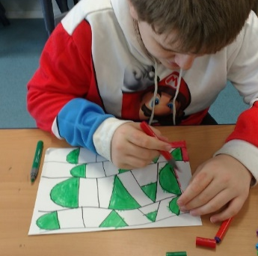

Take a line on a roller coaster ride.
Use a pen, a black marker, or a length of string dipped in coloured glue.
Loop the loop and colour in the spaces
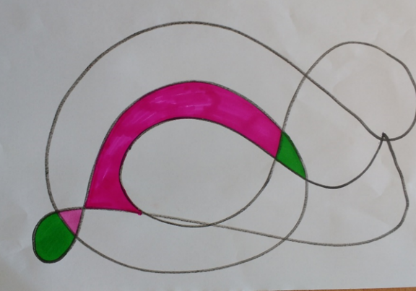
Recreate The Scream by Edvard Munch

People on Rollercoasters often scream
Look at the famous picture called The Scream by Edvard Munch
Think of how you could reproduce this picture
You could paint it or use something else
In these examples, people have used laundry, a potato and fruit and veg!
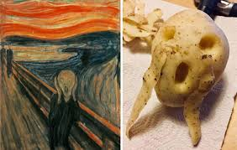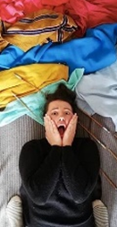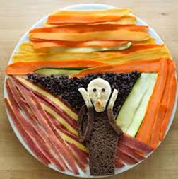

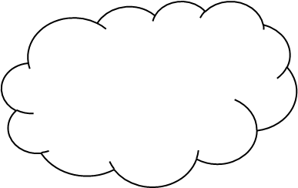
Design / decorate a roller coaster car
Make puffy paint :
¼cup of poster paint
¼ cup of white PVA glue
¼ cup of shaving foam

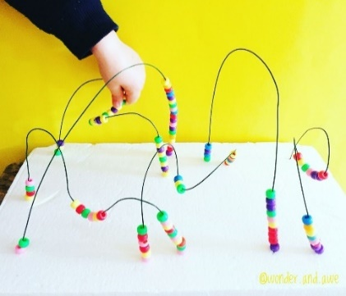
Make a bead roller coaster sculpture
Using garden wire, beads and a polystyrene block or a cork to stick the ends of the wire in to.

Make a theme park inspired paper sculpture
Cut, fold, curl, twist and tear strips of paper
Practice some paper sculpting techniques
https://www.youtube.com/watch?v=kpqjB_ocFlE

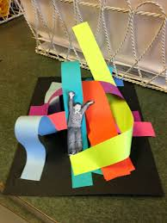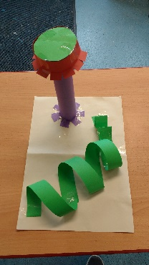

Spinning splatter picture
The Enterprise ride at Alton Towers is a zero gravity 360-degree giant spinning wheel
Make a paint splattering spinning top 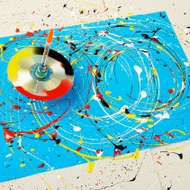
https://d86272xpepdkd.cloudfront.net/d7173aa6-ab87-47a9-9949-0639e5bbf9e6/Spinning_painter_header_vid.webm
What you need
• A recycled CD • Sticky tape or masking tape • Rubber bands
• A pen that will fit through the hole in the disk • 4 coins of the same size
• Acrylic paint, poster paint or inks • Water • A pot to mix the paint in.
• Brushes and an old spoon to mix and drop the paint • A large piece of paper

1. Tape coins to the underside of the disc Space them equally so they are balanced.
2. Position the pen through the disc
3. Use elastic bands to secure the pen
4. Prepare your paint
Homemade paint recipe:
½ cup of flour
¼ cup of salt
¾ cup of water
Food colouring

5. Holding the spinner still, add your paint mixture
6. Get spinning!
7. You can keep spinning until all the paint has come off

Simple spin art
Put a paper plate in salad pinner.
Add paint as it spins! Watch how the colours mix

