Communication
Total communication is an approach, which includes all the ways we communicate:

- Eye contact
- Facial expression
- Body language
- Vocalisations
- Hearing
- Touch
- Smell
- Taste
- Speech
- Symbols
- Photos
- Drawings
- Objects
- Written words
- Art
- Music
- Contextual clues
- Signs and gestures

Everyone communicates using at least one of the ways mentioned above. We all communicate in different ways and each way should be equally respected and encouraged. Non-verbal communication can be just as effective as speech. For example, Turning your head away when someone puts a cup to your mouth is as clear a message as saying, “I don’t want a drink”. However, communication is a two-way relationship and it will only be successful if the communicator and their partner are using the same ‘language’. Sometimes an individual’s way of communicating may be subtle and hard to recognise. It is very important that you spend time getting to know the person you support so they can show you and you can recognise their personal communication patterns.

Communication Activities

Simon Says
This game is a fun and an interactive way for children to learn about parts of the body and get some exercise! It can also improve their listening and observation skills.
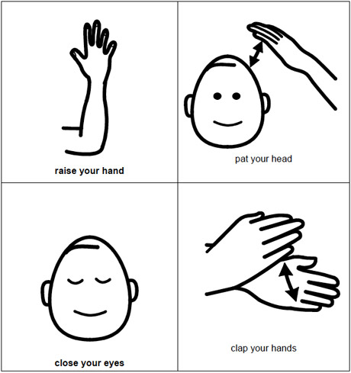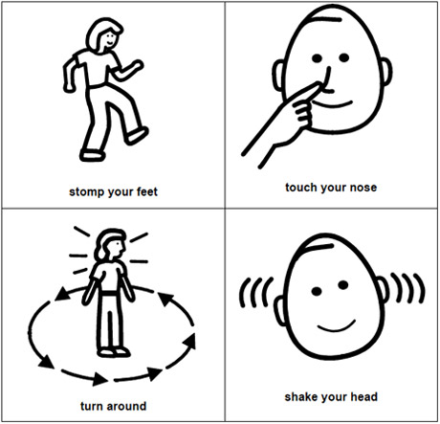
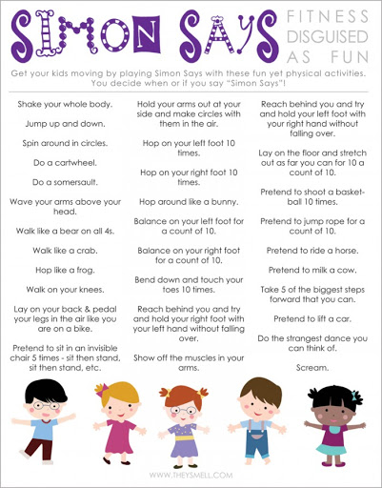
The Rain Game
This game signifies a rainstorm starting soft, getting louder and louder until it is pouring, with lightning and thunder, and then the calm after the storm when it is quiet again. It can also improve their listening and observation skills.
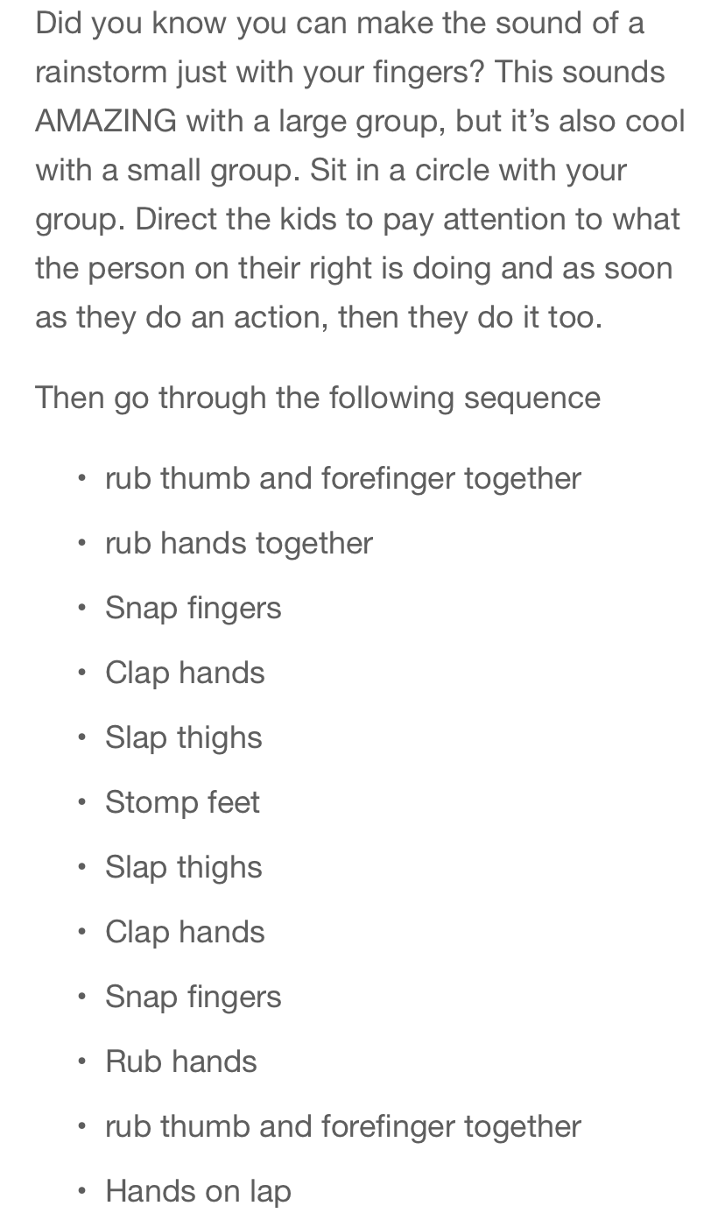

Tin Can Walkie Talkies / Phones
A lovely craft activity to encourage listening and speaking skills. Long before the telephone was invented, people found that they could get two empty tin cans, attach them together using string and speak to each other over pretty long distances. These have become to be called Tin Can Phones and the chances are that you made one of these as a kid yourself.

For each walkie-talkie, you will need two used, open-ended and clean tin cans and a length of string. You will also need a nail and a hammer to make a hole in the bottom of each can. Start by turning both cans upside down. Use the hammer and nail to make a hole in the bottom of each can. Put one end of the string through the hole of one of the cans. Secure the string by tying a knot in the string inside the can. Repeat with the other end of the string and the remaining can. Have two children each hold a can and walk apart until the string is tight. One-child talks into his can. The other puts an ear to the can and listens. He should be able to hear what was said.

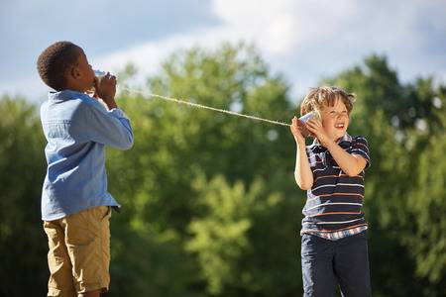

Signalong
Discussion pictures are a useful way of setting sign vocabulary in context and providing a scaffold to elicit further vocabulary. Enjoy a day at the beach!
https://www.signalong.org.uk/filemanager/Freebie%20Friday/20.07.10_the_beach_activity.pdf

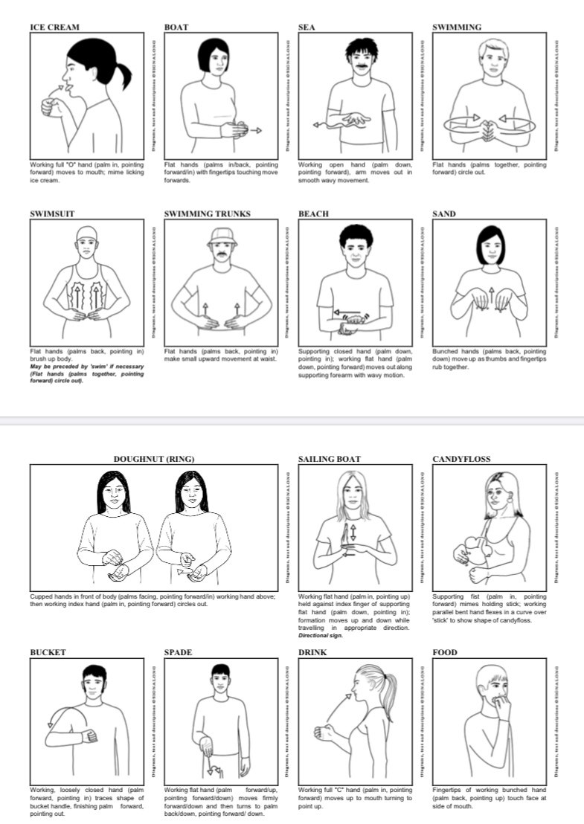

Objects of Reference – multisensory communication
Objects of Reference are objects used to represent a person, activity or event. Objects are concrete and permanent and offer lots of sensory information. They do not rely on processing verbal information or memory. Have a go at making your own OoR this summer and using them around the house or when out and about,

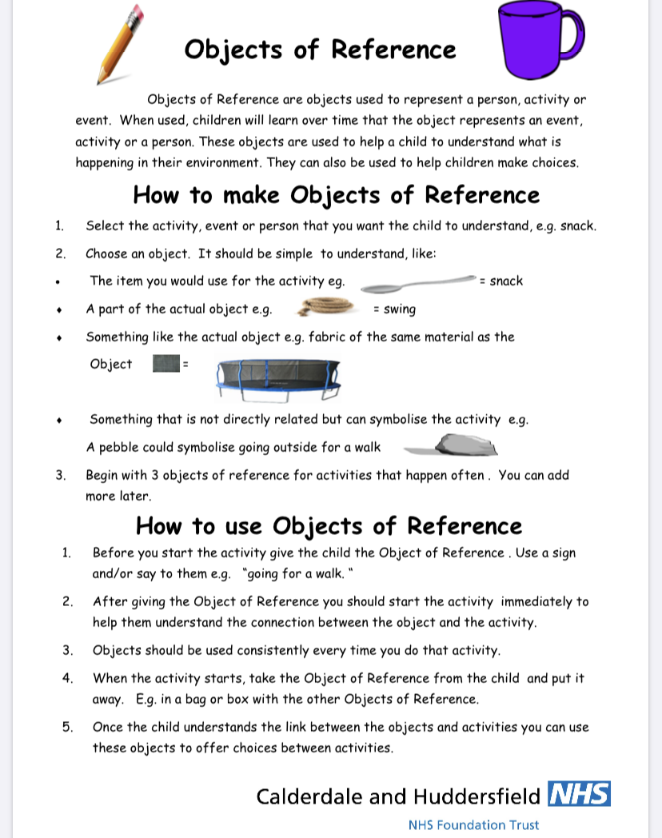

Pizza Massage - Communication through touch
A multi-sensory massage, increasing levels of engagement in all areas.
Who doesn’t love pizza?! Enjoy. https://www.youtube.com/watch?v=MlCBCLaybpw

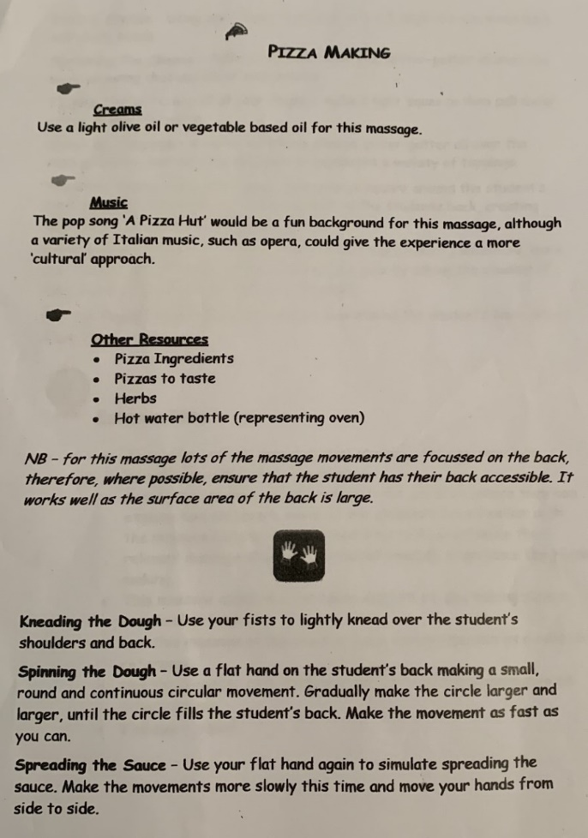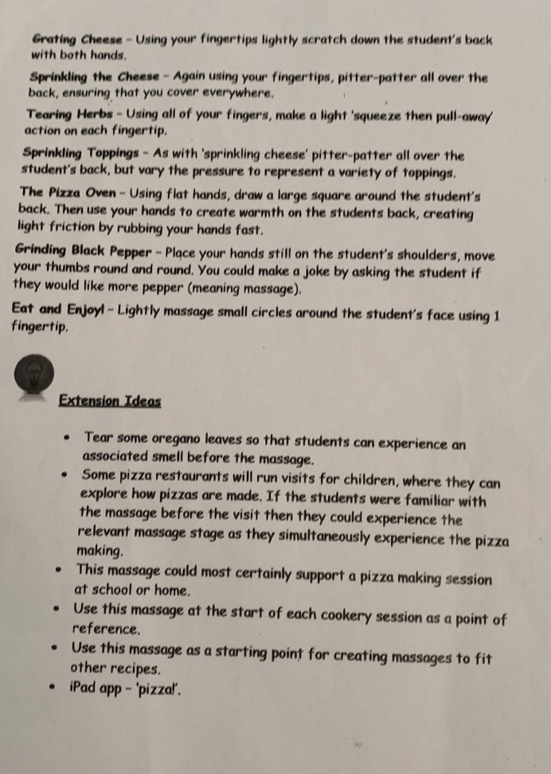

Intensive Interaction
Summary - Intensive Interaction is a practical approach to interacting with people with learning disabilities who do not find it easy communicating or being social. The approach helps the person with learning difficulties and their communication partner to relate better to each other and enjoy each other's company more. It helps them develop their communication abilities. In Intensive interaction the carer, support worker, speech and language therapist or teacher works on being a better communication partner and so supports the person with learning disabilities develop confidence and competence as a communicator. Intensive interaction is a fun process. The communication partner is guided by what we know about how communication ordinarily develops for young children. S/he applies this knowledge in a way that is sensitive and respectful to the person with learning disability, whatever their age.
https://www.mencap.org.uk/sites/default/files/2016-11/Intensive%20Interraction%2004.pdf

Social Communication –
Eye Contact
1. Have a staring contest
Making a contest out of making eye contact with you can challenge some children (especially if they have a competitive streak).
2. Eyes on The Forehead
When you are hanging out with your child place a sticker of an eye or a pair of eyes on your forehead. Encourage them to look at the stickers. It may not be exactly looking at your eyes but it is training them to look in the right direction in a funny, less threatening way.
3. Swinging
Try making eye contact as your child swings on a swing. Make a game of it where the child tries to reach you with their feet. The sensory input may be calming and allow them to focus more on you.
Idioms
Idioms, are very confusing!
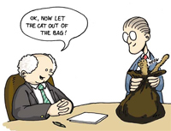
(is that an idiom?).
Books about Idioms
There are many great books that illustrate and explain idioms. Try In a Pickle And Other Funny Idioms by Marvin Terban. It gives a funny literal illustration and then explains the history of the phrase. Use such books as a launching pad. Have your child make their own book of idioms that they hear. When you use one regularly such as “That’s a piece of cake” have children make their own page.
Online
There are many websites that list idioms or have games to try guessing what the idiom really means. Check out Idiom Site, Fun Brain or vocabulary.co.il
Memory or Matching Game
Write down idioms on one set of cards and their meanings on another. Have the child try to pair them up. You could also add in the literal picture of the idiom to visualize what the idiom that is being used actually looks like.
Reading Faces / Interpreting Emotions
This skill is important at home and in school. Many misunderstandings arise from children misinterpreting the emotions of others. Sometimes children can be confused by what a particular look means. They may easily mistake a look of disappointment and think someone is angry, or they may mistake a nervous expression for a funny one.
Emotion Charades
Instead of using movie titles, animal or other typical words, use emotions. Write down feeling words on pieces of paper – or, print out and cut up the worksheet below. Take turns picking a slip of paper and then acting out the word written on it. You could substitute written words for pictures showing the emotion. If children prefer, you can draw the emotion rather than act it out like in the game Pictionary. You can make it harder by setting a rule that you cannot draw the emotion using a face. Instead, they have to express the feeling by drawing the body language or aspects of a situation that would lead to that emotion (e.g. for sadness, you can draw a child sitting alone on a bench, or a rainy day, etc.)
Face It
Face games are a way to work on social interaction. Like in an acting class, you can try “mirroring”: Touch your nose or stick out your tongue and have him or her imitate you. Make funny faces that the child can copy. Children with social skills deficits often have trouble reading expressions and interacting socially, so activities that get them more comfortable with these situations are a great idea.

