Challenge Activity Planner - Summer 2020
Day | Activity
Monday | Blowing up balloons using Science!  You will need: Empty, clean & dry 500mls drinks bottles, white vinegar, balloons (one for each bottle), bicarbonate of soda, a funnel and a spoon. You can also use some food colouring if you like.  This experiment demonstrates a chemical reaction, which happens when a solid (bicarbonate of soda) is added to a liquid (vinegar), and creates a gas (carbon dioxide).  Spend some time exploring liquids, solids and gases through playing in sensory trays of water, sand, rice etc and experiencing balloons both inflated and deflated, fans, windmills and bubbles (all which need/create a movement in, air)  Watch the YouTube clips on how to conduct the experiment. Observe safety rules – do not explore the ingredients by taste and do not touch them and then touch your face.  https://www.youtube.com/watch?v=Zq-jeGOzZs4  https://www.youtube.com/watch?v=Cfh7TftRf7g  Organise your bottles so you can pour vinegar into them – about a quarter full. Use the funnel to add three or four spoons of bicarbonate of soda to each deflated balloon. Stretch the necks of the balloons over the tops of the bottles, keeping the bicarbonate of soda in the balloon. When all the balloons are attached to the bottles, tip them up so the bicarbonate of soda tips into the bottles. The reaction produces carbon dioxide, which will inflate the balloons. Experience the balloons blowing up and if possible, detach and tie them so you can play with them.  You can repeat the reaction without the balloons, adding bicarbonate of soda to vinegar, coloured by food colouring in the bottles. The reaction creates a ‘volcano, which erupts out of the top of the bottle. Finish the session by exploring the sensory trays of solids and liquids and play with items which require air.  Yummy Balloon Bowls  https://www.bbcgoodfood.com/recipes/chocolate-balloon-bowls  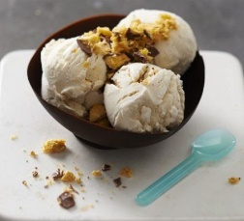  Follow the recipe above to make your own chocolate bowls with a balloon.  Ingredients  300g chocolate (we used dark, but choose your favourite)  A dessert of your choice (we used ice cream and honeycomb)  You will also need  4 small balloons  Method  - Break the chocolate into small pieces. Put in a bowl suspended over a pan of simmering water and leave to melt. Remove from the heat and leave to cool for 5 mins. Meanwhile, blow up your balloons – you want each bowl to be about 10cm wide, so try to pick small balloons and don’t blow them up too much. Tie with a knot.  - Line a baking tray with parchment. Holding the knotted end of the balloon, dip it into the melted chocolate to create your bowl shape. Stand it on the tray and hold the balloon for a few secs until the chocolate pools around the base allowing you to let go of the balloon. Continue with the remaining balloons. Chill for at least 30 mins or until set.  - When the chocolate has set, pop the balloons and carefully peel them away from the bowls. Fill with your chosen dessert – ice cream is good because it keeps the bowls cold.  Papier mache Hot air balloon– see this link for pictures https://www.firstpalette.com/craft/hot-air-balloon.html  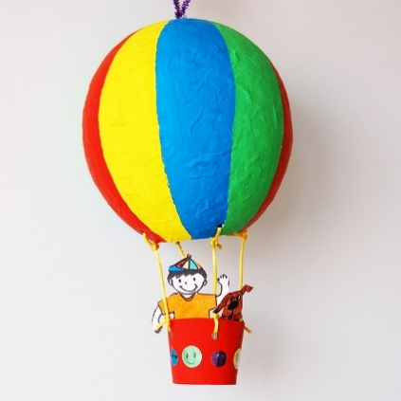  SUPPLIES NEEDED  - Oval balloon  - Paper (newspapers or paper for recycling)  - Papier mache paste  - Hole punch  - Paper cup  - Strings  - Scissors  - Poster paint or acrylic paint  - Paint brush  - Stickers, foam shapes, glitter glue (optional)  STEPS  1 Papier mache around a balloon.  Make a papier mache using an oval balloon as the mould.  2 Widen the hole.  Once the papier mache is completely dry, pop the balloon.  With a pair of scissors, widen the bottom hole on the papier mache to a diameter of about 2-3 inches. Remove the deflated balloon from the papier mache.  3Punch four holes.  Punch four evenly-spaced holes around the opening.  4Make a small hole on top.  Use the point of a pencil to make a small hole at the top of your papier mache.  5Loop one end of a pipe cleaner.  Use a pipe cleaner to make the handle at the top of your hot air balloon. First, make a small loop on one end of a pipe cleaner.  6Position the pipe cleaner.  Next, insert the straight end of the pipe cleaner from inside the papier mache—in through the large opening at the bottom and out through the small hole on top. Pull all the way through. The loop on the pipe cleaner serves as a stopper.  7Loop the top of the pipe cleaner.  Loop the protruding portion of the pipe cleaner at the top of the papier mache to create a handle for your hot air balloon. Fasten the end in place.  8Prime the papier mache.  Paint your papier mache with white acrylic paint or poster paint. This layer serves as the primer. It helps cover the newsprint on your papier mache and prepare it for the final colors of your hot air balloon. Let the paint dry completely.  9Paint the papier mache.  Use poster paint or acrylic paint to paint your papier mache with the final colors and design for your hot air balloon.  10Trim a paper cup.  Create a basket for your hot air balloon either with a plastic yoghurt cup or a small paper cup. Trim the paper cup to the desired height.  11Punch holes.  Punch four evenly-spaced holes around the mouth of the paper cup.  12Paint the cup.  Paint the paper cup with acrylic or poster paint. If your paper cup has a glossy or waxy finish, use acrylic paint.  13Connect the basket to the balloon.  Attach the basket to the papier mache by tying strings to connect the holes on the balloon to those of the basket.  14Add some fun details.  Decorate your hot air balloon with stickers, foam shapes or glitter glue. You can even draw and cut paper people and animals to ride in your hot air balloon!
Tuesday | Exploring and making bubbles  Experience/explore bubbles. Bubbles of different sizes, bubbles blown from a small bubble wand, large bubble wand or through a bubble machine.  Investigate and experiment making your own bubbles or having bubbles made for you of different sizes and/or colours.  You will need: a large jar or bowl, water, washing up liquid, spoons, plastic drinks bottles, a highlighter pen, garden canes or doweling rod, string, pipe cleaners, food colouring and old socks.  Watch the video clips to learn how to create giant bubbles using sticks and string, glowing bubbles using highlighter markers, bubbles on the table using drinks bottles and bubble snakes, using plastic bottles, socks and food colours.  https://www.youtube.com/watch?v=EfhmSGT0xqI  https://www.youtube.com/watch?v=NJqPHI8z2hk  https://www.youtube.com/watch?v=iZON2cN_Szc  Explore the bubbles made in each experiment by watching and feeling them. Try and fill/get a family member to fill a tray with the bubbles from the plastic bottle with the sock over the end of it and see if you can pop all the bubbles or search for hidden toys in the bubbles  Investigate if you can change the shape of bubbles by making your own bubble wands from pipe cleaners. Make bubble wands which are square, triangle, rectangle or any other shape you can think of and see what happens when you use them to blow bubbles.  Bubbly Food  https://www.bbcgoodfood.com/recipes/crumpets  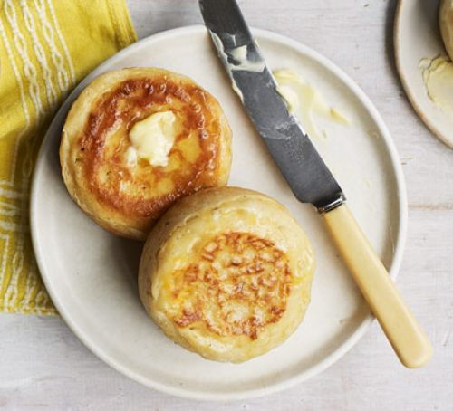  Crumpets  Ingredients  - 2 ½ tsp dried yeast  - warm 240ml milk  - 2 tbsp unsalted butter, melted  - 2 tsp sea salt  - 2 tsp caster sugar  - 470g plain flour  - ½ tsp baking powder  dissolved in 60ml warm water  - vegetable oil, to grease  - Butter or cheese, to serve  Method  - In a bowl stir together the yeast and 240ml warm water and let it stand for 5-10 mins. Add the warm milk, butter, salt and sugar. Add the flour and stir until the batter becomes smooth. Let stand for 30 mins.  - Stir in the baking powder dissolved in water, leave to rise for 20-30 mins.  - Grease a heavy-based frying pan with a little vegetable oil and heat over medium-low heat. Lightly grease 4 x 9cm diameter crumpet rings. Spoon batter into the rings so it comes halfway up the sides. Reduce heat to low, cover with an upturned deep frying pan to give the crumpets space to rise. Cook until the tops look dry, about 10-12 mins.  - Flip them over and cook for 5 mins until golden and firm. Repeat with the remaining batter. Serve toasted with butter or with cheese melted under the grill.  Look at the bubbles that have formed during the cooking of your crumpets and enjoy eating them together.
Wednesday | Exploring and making Slime!  Slime is created by mixing ingredients which create a scientific reaction, producing a stretchy, non-stick material which is great fun to explore and play with. You can use your slime to create an ocean activity, adding shells, plastic sea creatures and small pebbles to a tray with ocean coloured slime.  You can also cusutomise your slime, using glitter, beads, different colours etc  There are several ways to make slime, using ingredients such as PVA glue, water, liquid starch, Borax, saline solution, bicarbonate of soda. You will also need measuring cups, a big bowl and spoons to stir.  Each recipe produces a different consistency of slime, but all are fun to explore and play with and shouldn’t leave any mess behind.  https://littlebinsforlittlehands.com/liquid-starch-slime-easy-sensory-play-recipe/  https://littlebinsforlittlehands.com/how-to-make-borax-slime-easy/  https://littlebinsforlittlehands.com/make-homemade-slime-saline-solution/  https://littlebinsforlittlehands.com/make-ocean-slime-summer-science-activity/  Watch the videos and have a go at making some different slimes or let someone help you make them. Explore/experience the slimes by playing with them/being supported to handle/touch them. Show how you feel about each one through your facial expressions, your reactions or with symbols/words.  If appropriate, you could do a a checklist to compare & grade the different slimes. Think about things such as their stretchiness, how wet/sticky they feel, how easy they are to make, how well they take colour and how effective they are with glitter in them. You could decide which is your favourite slime.  Slimy food  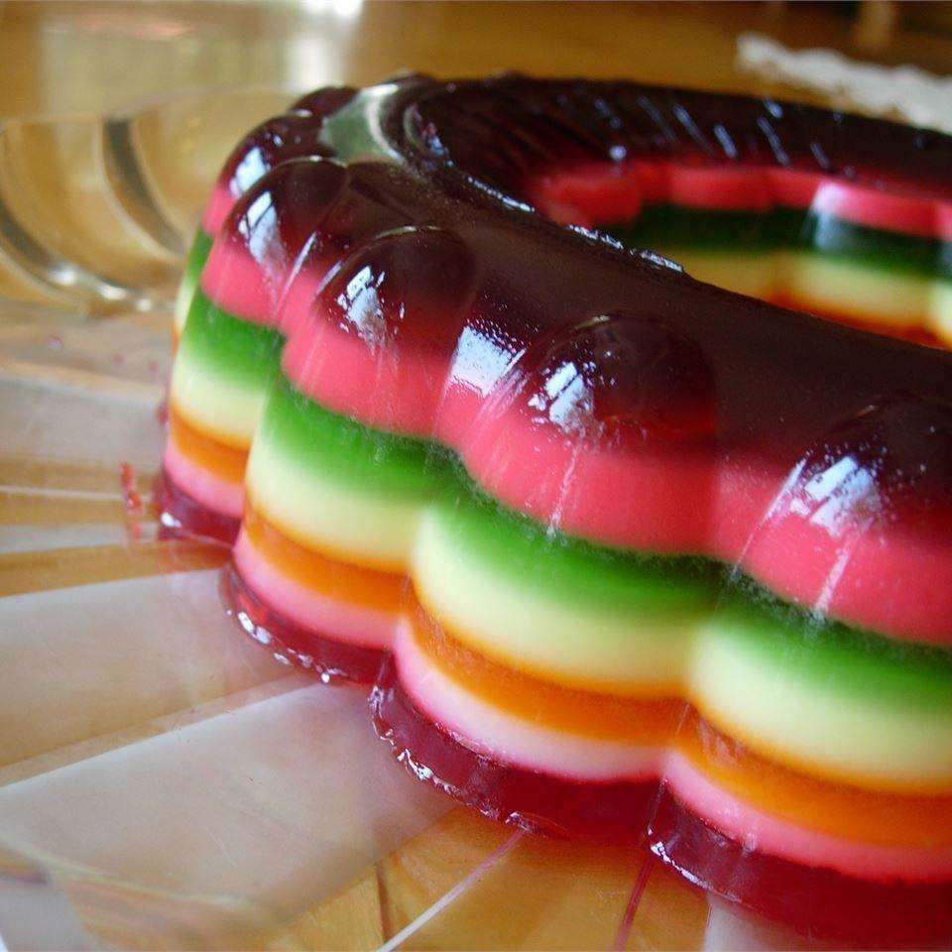  Rainbow Jelly  Make this as big or as little as you like and with as many layers as you like.  Ingredients  Serves: 11  - 1 (135g) packet blackcurrant flavoured jelly  - 1 (135g) packet lime flavoured jelly  - 1 (135g) packet orange flavoured jelly  - 1 (135g) packet strawberry flavoured jelly  - 1 (135g) packet raspberry flavoured jelly  - 1 (135g) packet lemon flavoured jelly  - 1 (135g) packet pineapple flavoured jelly  - boiling water  - 375ml evaporated milk  Method  Prep:20min › Ready in:20min  - For the jelly layers: Make the blackcurrant, lime, orange and strawberry jellies in separate bowls using 450ml of boiling water. Stir well and let each one cool to room temperature.  - For the creamy jelly layers: In separate bowls, prepare the raspberry, lemon, and pineapple flavored jellies with 225ml boiling water and add 125ml evaporated milk when each cools to room temperature.  - Pour the room temperature blackcurrant jelly into a large glass bowl or glass casserole dish: place in the fridge until it has just set. Follow with a layer of the next flavour, allowing each layer to cool before adding the next.  If you don’t like to eat Jelly you could make this into a sensory activity. Explore how slimy the jelly feels!
Thursday | Homemade Lava Lamps  Look at and explore liquid. Use a water tray to explore water. Add colour to the water, play pouring, splashing, squirting water. Add washing up liquid or bubble bath and explore how this changes the water. If appropriate, talk about how the washing up liquid/bubble bath, mixes completely into the water. Introduce oil as another liquid. You can use baby oil or cooking oil. If you are feeling brave and have protective clothing/aprons, explore the feel of oil and how it moves when pouring it. Compare with water.  You will need: empty plastic bottles or wide necked jars, baby or cooking oil, food colouring and Alka Seltzer tablets.  - Investigate how sometimes liquids will not mix. Add oil to the plastic bottles/jars. Fill them about two thirds full with oil.  - Add water to the bottles, leaving about 3cm gap at the top  - Add a few drops of food colouring to the bottle  - Break an Alka Seltzer tablet into 4 pieces  - Add a piece of the Alka Seltzer to the bottle and watch the ‘magic’ happen. Once the reaction slows down, add another piece to start it up again – don’t put too much Alka Seltzer into the bottle at once, otherwise the liquids go cloudy.  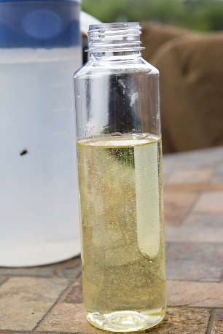  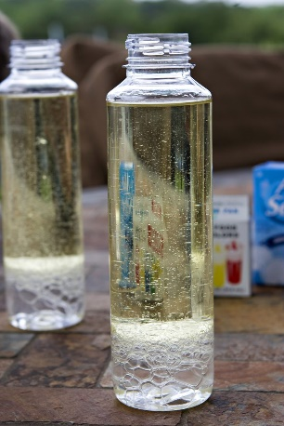  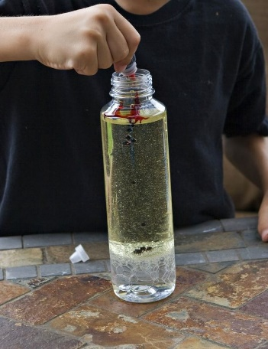  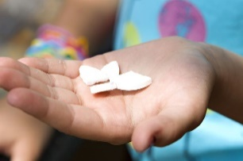  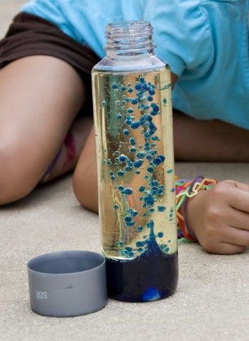  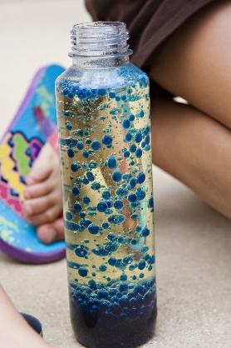  Chocolate Lava Cake  https://www.bbc.co.uk/food/recipes/chocolate_lava_cake_79464  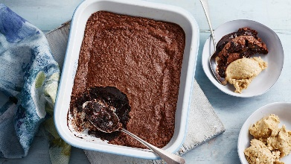  For the chocolate lava cake  - 175g/6oz butter, plus extra for greasing  - 200g/7oz dark chocolate, chopped  - 3 large free-range eggs  - 125g/4½oz caster sugar  - 30g/1oz plain flour  For the ice cream  - 40g/1½oz butter  - 75g/2¾oz breadcrumbs  - 4 bananas, chopped and frozen  - 3 tbsp smooth peanut butter  Method  - Preheat the oven 180C/160C Fan/Gas 4. Grease a 20-25cm/8-10in baking dish with a little butter.  - For the cake, melt the butter in a saucepan. Remove from the heat and gently stir through half the chocolate until melted.  - In a mixing bowl, whisk the eggs and sugar until they become pale and thick. Pour in the chocolate mixture, then sift in the flour. Add the remaining chocolate and using a spatula, fold the mixture together until it is evenly combined. Pour into the prepared dish.  - Bake for 20 minutes. When cooked, the pudding should be slightly firm around the sides but the centre should still be wobbly.  - Meanwhile, for the ice cream. Melt the butter in a frying pan, add the breadcrumbs and cook until golden-brown. Set aside to cool.  - Put the bananas and peanut butter in a food processor and mix until smooth and creamy. Put in a bowl with the breadcrumbs and fold through.  - Serve the lava pudding immediately with the ice cream.  Make an erupting volcano – full instructions on this link  https://www.learning4kids.net/2012/04/11/how-to-make-a-homemade-volcano/  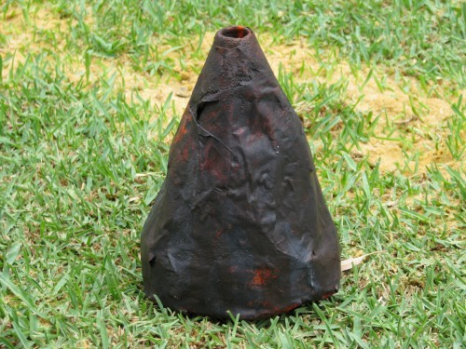  WHAT YOU WILL NEED  You will need an empty plastic bottle (this is 1 litre bottle), newspaper torn up in strips, PVA craft glue, masking tape and a container for the water and glue mixture.  To make the lava to mimic that of a real volcano you will need bicarbonate soda, red and yellow food colouring (or orange) and white vinegar.  To make the basic shape of a volcano I cut the middle of the plastic bottle out and then overlapped the two ends together securing it with masking tape. To give the volcano a more pyramid/mountain shape I then rolled newspaper into a tube shape and wrapped it around the base of the plastic bottle and securing it all with masking tape.  Time to get messy: applying Paper Mache to our volcano using small strips of newspaper dipped into a gluey water mixture. We also folded a small amount of newspaper into the opening of the bottle but making sure there was enough room to add our bicarbonate soda and vinegar later.  Tip – keep some old flannels or cloths handy for the kids to wipe their hands on.  When the Paper Mache is dry, paint the volcano. While we were waiting for the paint to dry we had a practise run to see how much bicarbonate soda and vinegar would be needed for the homemade volcano. To give you a bit of an idea, we used 4 tablespoons of bicarbonate soda and 1 cup of vinegar mixed with some red and yellow food dye and this seemed to work fine.  Sift the bicarbonate soda into the funnel and pour in the vinegar…..you have to be super quick to get the funnel out.  Making a homemade volcano is a fun and simple process that kids will take on a sense of pride, ownership and achievement of what they have accomplished. All this while learning new things and practising some basic skills with an almighty eruption at the end. We repeated the eruption 3 times!  SOME SIMPLE FACTS ABOUT VOLCANOES:  - A volcano is a mountain that erupts.  - Rock under the earth’s surface is so hot that it melts. This melted rock is called magma.  - Erupting magma is called lava.  - Volcanoes become bigger every time they erupt as the lava cools and makes a new layer of rock.  - Volcanoes can erupt under water and form new islands from the cooled lava.  - Volcanoes can be found on the moon and other planets.  - There are more than 500 active volcanoes on Earth.
Friday | Get Creative with Chalk!  Explore the properties of liquids and solids by making your own chalk paint  You can make your own chalk paint or let someone else help you to make some.  You will need: Cornflour, food colouring, water, a bowl and spoon.  Use equal quantities of cornflour and water and stir well until mixed. If the mixture seems too thick to be able to paint with, add a little more water. Add a few drops of food colouring to make the desired colour. This chalk paint will wash away, although, it may take a couple of rainy days for all the colour to go.  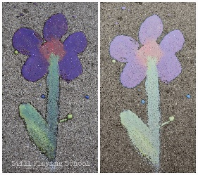  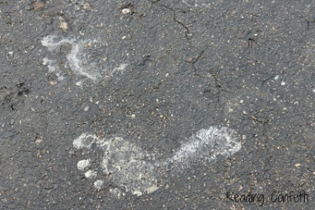  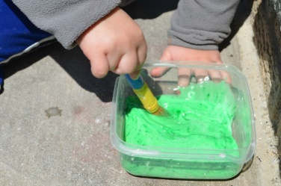  Explore the marks and patterns you can make with the chalk paint on the path/patio in your garden. Use a brush or your hands and feet.  For a different activity where you can explore changes of state, make ice chalk. Make the chalk paint and pour it into ice cube trays, before putting it in the freezer. Explore what marks you can make with the frozen chalk as well as exploring it as it starts to melt. Leave the chalk cubes in the sun and watch as they change from a solid to a liquid and the colours melt together.  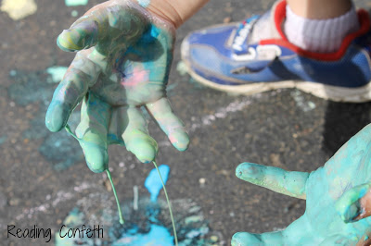  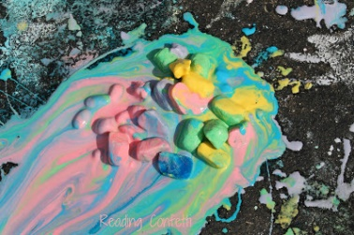  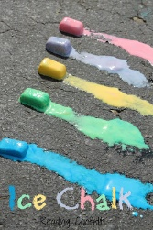  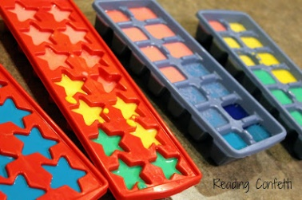  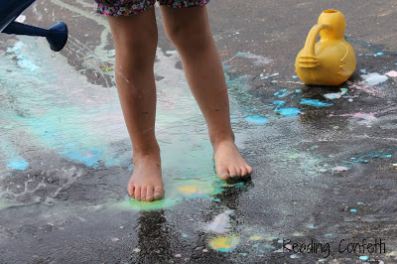  You can also have a go at making glow in the dark chalks. Just add some glow in the dark paint to the cornflour and water when making the chalk paint and paint patterns on your path, patio or on black paper. See if you can see the patterns and pictures, you have made when it is dark.  Liquid to Solid Food  Observe how these recipes go from liquid to solid by either heating or freezing.  Omelette  https://www.bbcgoodfood.com/recipes/basic-omelette  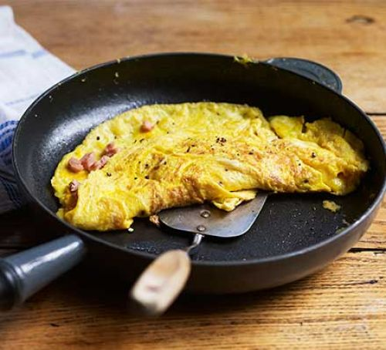  Ingredients  - 3 eggs beaten  - 1 tsp sunflower oil  - 1 tsp butter  Method  - Season the beaten eggs well with salt and pepper. Heat the oil and butter in a non-stick frying pan over a medium-low heat until the butter has melted and is foaming.  - Pour the eggs into the pan, tilt the pan ever so slightly from one side to another to allow the eggs to swirl and cover the surface of the pan completely. Let the mixture cook for about 20 seconds then scrape a line through the middle with a spatula.  - Tilt the pan again to allow it to fill back up with the runny egg. Repeat once or twice more until the egg has just set.  - At this point you can fill the omelette with whatever you like – some grated cheese, sliced ham, fresh herbs, sautéed mushrooms or smoked salmon all work well. Scatter the filling over the top of the omelette and fold gently in half with the spatula. Slide onto a plate to serve.  Make your own yoghurt lollies  https://www.abelandcole.co.uk/recipes/frozen-yogurt-lollies  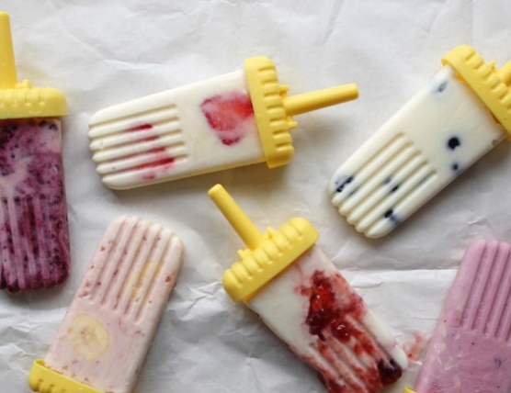  Ingredients  - 450-500ml yogurt (A handful of fresh fruit (like summer berries)  - A few tbsp of jam (optional)  Method  1.Basically, you can just pour your favourite yogurt into an ice lolly mould and freeze it. If you’re using natural yogurt, you'll need to sweeten it with honey or a swirl of jam.  2.We experimented with lots of different flavour combos. These are some of our favourites: - Greek style natural yogurt with honey + crushed raspberries or blackberries folded through it. - Vanilla yogurt + fresh blueberries dotted through the lolly. - Strawberry yogurt + thin banana slices. - Natural yogurt + generous swirls of strawberry jam.  3.To make your lollies really striking to look at, pour the yogurt in the lolly mould first. Then, add the fruit or swirl the jam into it, so you can see it along the sides of the lolly moulds. This is a bit messy but they look great afterwards.  4.Freeze for at least 2 hours, or till frozen solid. Run under warm water to help you ease the lolly from the mould  Make sure you talk about how the freezing makes the lolly go from liquid to solid and then putting it in your mouth, where it is warm, will make it go back to a liquid.

