We would like to introduce to you to our team who are here to help.
You will have a worker that will help you to plan for your next steps. There are lots of different options that you can explore when you leave education (normally around age 19) and you will be supported through this.

This is Emma Surtees, Practice Manager

You can call Emma on 01625 374948 or email her
Emma.Surtees@cheshireeast.gov.uk

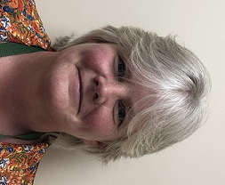 | This is Fiona Bogues, Social Worker  You can call Fiona on 01260 387709 or email her  Fiona.Bogues@cheshireeast.gov.uk
This is Christopher Hyamson, Social Worker

You can call Christopher on 01260 375458 or email him Christopher.Hyamson@cheshireeast.gov.uk

This is Karen Potts, Social Care Assessor

You can call Karen on 01270 375286 or email her
Karen.Potts@cheshireeast.gov.uk

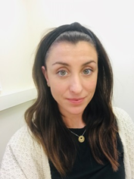 | This is Leonie Salehi-Mojdeh, Social Care Assessor  You can call Leonie on 01625 374085 or email her Leonie.Salehimojdeh@cheshireeast.gov.uk
This is Sarah Jacklin, Local Area Co-Ordinator

You can call Sarah on 07717 733349 or email her Sarah.Jacklin@cheshireeast.gov.uk

